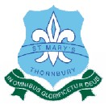
Contents
ANNUAL
REPORT
TO THE SCHOOL
COMMUNITY

REGISTERED SCHOOL NUMBER: 1108

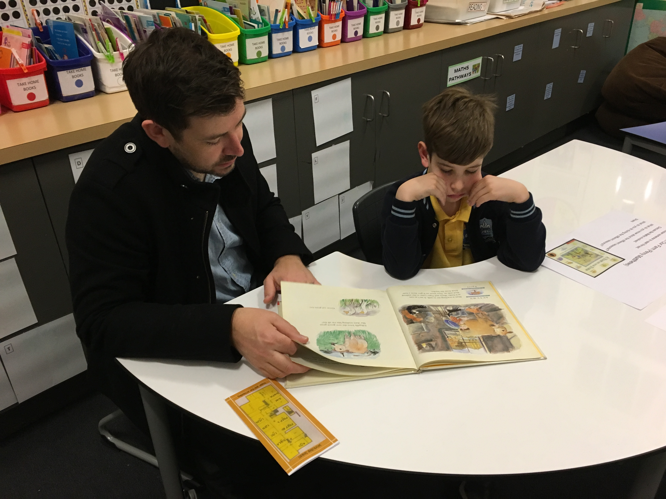

2019
ST. MARY’S
THORNBURY
Contact Details 2
Minimum Standards Attestation 2
Our School Vision 3
School Overview 4
Principal’s Report 5
Parish Priest’s Report 6
School Education Board Report 7
Education in Faith 8
Learning & Teaching 9
Student Wellbeing 10
Child Safe Standards 12
Leadership & Management 13
School Community 14
Future Directions 15
School Performance Data Summary 16

Contact Details
ADDRESS | 2 Mansfield St  Thornbury
PRINCIPAL | Dino De Propertis
PARISH PRIEST | Fr Shabin Kaniampuram
TELEPHONE | (03) 94845333
EMAIL | principal@smthornbury.catholic.edu.au
WEBSITE | www.smthornbury.catholic.edu.au
E NUMBER | E 1097

Minimum Standards Attestation
I, Dino De Propertis, attest that St. Mary’s Thornbury is compliant with:
- All of the requirements for the minimum standards and other requirements for the registration of schools as specified in the Education and Training Reform Act 2006 (Vic) and the Education and Training Reform Regulations 2017 (Vic), except where the school has been granted an exemption from any of these requirements by the VRQA
- Australian Government accountability requirements related to the 2019 school year under the Australian Education Act 2013 (Cth) and the Australian Education Regulations 2013 (Cth)
- The Child Safe Standards prescribed in Ministerial Order No.870 – Child Safe Standards, Managing Risk of Child Abuse in School.
9 May 2020

Our School Vision

St Mary’s Parish Primary School Thornbury, as a sign of the presence of God, proclaims Gospel values centred on Jesus Christ as the model for life. We are a welcoming spirit filled community that views the future with optimism. By respecting the diversity and uniqueness of each person, we promote the self-worth and connectedness of individuals. We value shared leadership that creates the structures for a broad, Inclusive and developmental curriculum within a safe, supportive and well-resourced environment. Together with parents, we strive to provide life-long learners with the strategies and skills that instil confidence, equip them to journey towards their future and positively contribute to a changing world.

School Overview

Inspiring Learners
St Mary's School has an enrolment of approximately 246 students arranged into ten multi-age classes.

Our inclusive approach is reflected in the wide range of cultural, social and religious backgrounds of our children. The main cultural groups represented in the school include, Vietnamese, Lebanese, Greek and Italian.

We believe that parents are the primary educators of their children and thus we emphasise and encourage the partnership between parents, children and the school and encourage parental participation in the school in a wide range of activities. St Mary’s is a Visible Learning School where we encourage student voice and design our individualised programs around child- centred learning.

We offer a sacramental program providing for Reconciliation, Eucharist and Confirmation. We celebrate liturgy regularly as both individual classes and as a whole school. We also join with the Parish for special weekend liturgies several times a year, such as Grandparents Day and School Open Day.

The school provides specialist teachers in the areas of Library, Italian, Mandarin, Physical Education, Art, Performing Arts and Information and Communications Technology. We have a strong emphasis on Literacy and Numeracy. We offer Intervention programs including Reading Recovery and Mathematics and Literacy Intervention and comprehensive student wellbeing, special needs program and extension program. We have a strong Physical Education program including inter-school sports and representation at district and state levels in selected sports. The children are well supported to discover their strengths and achieve success.

Our historic building houses many modern facilities, including a state of the art computer laboratory and networked computers in all classrooms. We offer a Before and After School Care program to assist busy parents balance their work and home commitments and work closely with the Parish to build a better and more vibrant community.

St Mary’s is an inclusive community and openly welcomes all who want to participate and become part of our community

Principal’s Report
At St Mary’s we recognize and believe that we are life- long learners and as such, educators have the privileged role of inspiring children to be lead learners. Visible Learning Professional Development has been the focus and staff have been involved in the delivery of extensive professional development throughout the year. This has seen us change our thinking and led to the design and implementation of a curriculum which truly meets the needs of individual children. In 2019 we continued to participate in the Evidence Based Learning program which demonstrated a learning culture embedded in the school that allows for critical thinking and questioning with the goal of improving student engagement. Staff completed Professional Development in Evidence Based Learning and 6 staff went to Ottawa to see this in action. In 2019, we continued with the implementation of one on one chromebooks for children in Year 3 to Year 6. The program allows children to research and develop Digital Portfolio’s as well as set individual goals for learning and provide ongoing assessment and tracking of children’s progress. These are uploaded using the Seesaw website and available for parents using their unique log in.
Our focus during 2019 was to build leadership and learning in Literacy and Numeracy education. Staff received extensive professional development with the assistance of key personnel in areas of literacy and numeracy and we commenced a focused attempt to improve explicit learning and teaching in this area. This has led to teachers using data closely to monitor children’s progress and design individual learning plans to their needs.
We continue to build on the links with the community and ensure that parents are valued as the primary educators of their children. We encourage parent partnership and developed a data base of skills and expertise to use in our daily teaching and learning. This has resulted in a greater input from parents and their involvement in implementing a curriculum which is alive and relevant.
We are very fortunate to work in an environment which is comfortable and conducive to learning. Our new facilities have created new working spaces for staff, students and parents.
In 2019, we celebrated many achievements. We acknowledged the past and look forward to the future in ensuring that we continue to provide an education that is second to none.

Education in Faith

Goals & Intended Outcomes
To strengthen the identity and mission of the school as a learning community that is authentically Catholic in a contemporary environment.
That all learners are engaged in learning in RE and make connections to life and faith within and beyond the community.
That staff capacity to design and implement rich RE curriculum that helps learners make sense of life and faith.

Achievements
Students from all year levels are involved in inquiry units / actions that will focus on social justice issues and sacraments.

The Leadership structure has created an opportunity for wider staff engagement and empowerment in leadership in this area. The team, led by the Education in Faith Coordinator is represented at the Leadership and Management Team level and share responsibility for delivery of many of the key improvement strategies designed to achieve the goals outlined in the School Improvement Plan 2018-2021.

This year the Religious Education provided for our school has endeavoured to equip the children to be fully engaged in the learning of our Catholic Faith. This has occurred through three major areas –:

- In the classroom as formal learning experiences; including Godly Play and Christian Meditation;
- By whole-school, class liturgies and prayer experiences that have occurred;
- In the way we as a community live out our faith.

The Religious Education curriculum in 2019 was designed to assist in the further implementation of the new Religious Education Guidelines. The staff, with the assistance of the Religious Education Coordinator, developed units of work in classrooms and which were built around developing students’ understandings
- The development of the “Good Shepherd Experience.” The continuing development of the “Good Shepherd Experience” is still a high priority for our junior school teachers. This pedagogy, also known as Godly Play, is used in most classes where the biblical story told this way is the way the children are able to make meaning and gain insights into scripture stories, Church teachings and Tradition. We have looked at developing sound texts to assist the implementation of the approach and organizing the equipment in a way that it is easily accessible.

- Reporting to parents. This is where teachers, students and parents were able to see growth in students’ understanding about Scripture and Tradition, about sign, symbol and ritual, and view and assessment tasks are developed to ensure correct data is generated that demonstrates the students’ understanding about Scripture and tradition; the understanding and use of sign, symbol and ritual; and ways of living and responding to the activity of God in the world. Clear report comments are written in response to these outcomes and used within the written report.

- The structure and important of the Scripture and Spirituality was addressed and teachers had the opportunity to deepen their understanding. This was done as space learning lead by the REC and the RE advisors and external facilitators.

- The St Mary’s Sacramental program had children receive the Sacrament of Confirmation, Eucharist and Reconciliation. We had a great response from parents attending the faith session and working together on the topic of Reconciliation, Eucharist or Confirmation. These evenings are led by our Parish Priest and supported by the Religious Education coordinator and classroom teachers.

Our faith is integral to the totality of school life and it gives witness to, and supports the growth in faith of the students in our care. All staff and students in our school community are responsible for revealing the love of God by their words and action
VALUE ADDED
Activities related to the Catholicity of our school which ‘add value’ to the achievement and spiritual development of our students include: daily prayer, class Masses and opportunity for Reconciliation, Religious Education lessons, Sacramental preparation programs, participation in the support of social justice issues, staff living their faith through participation and example, celebrating the Parish Feast Day, use of appropriate religious icons throughout the school.
Our 2019 CEMSIS data reveals that staff (97%) and students (71%) see many opportunities for action in the area of Social Justice and Christian Meditation.

Learning & Teaching

Goals & Intended Outcomes
To ensure that students are engaged, empowered and connected to school and the global community.
That all learning is focused on student growth and success.
That all student learning in Literacy and Numeracy is maximized for all cohorts.
That students are authentically engaged, have a voice and are encouraged to take ownership of their learning.

Achievements
Our Leadership structure has created an opportunity for wider staff engagement and empowerment in leadership in this area. The team, led by the Learning and Teaching Coordinator is represented at the Leadership and Management Team level and share responsibility for delivery of many of the key improvement strategies designed to achieve the goals outlined in the School Improvement Plan 2018-2021.

Planning and delivery of inquiry learning continues to develop as teachers are supported at planning level to explore new skills and strategies that will assist them in this area. As we work towards a more visible learning approach to curriculum, staff is beginning to negotiate the curriculum with students and use this and the information gathered through assessments to continue to plan appropriate units of work and activities designed to best meet the identified learning needs of their students.

Staff and students continue to work on improving curriculum delivery through a Visible Learning approach which caters for individual needs and focus on building capacity for independent learning to occur.

Collaboration continues across the levels with regard to meeting the identified needs of students in the areas of literacy and numeracy. The Literacy coordinator, Reading Recovery Teacher, Numeracy Coordinator and the Math’s Intervention Teacher continue to provide support to teachers in the planning, preparation, assessment and delivery of lessons in both these areas. The Learning and Teaching Coordinator, Special Needs Coordinator, Wellbeing Coordinator and Religious Education Coordinator also provide support to the teachers in their planning of other areas of the community.

The recording of school numeracy testing data (using Essential Elements) has helped teachers to review the areas of need and strategically place students in focussed groups where they engage in activities designed to meet their needs. Teachers have felt more confident with the planning and delivery of maths throughout the school as a result of this and targeted on site professional learning and mentoring discussions.

Both the special needs coordinator and the wellbeing coordinator have participated in the professional learning team meetings and supported teaching staff to prepare Individual Learning Plans (ILPs) and Personal Support Groups (PSGs) for the children identified as at risk. The preparation of these ILPs and PSGs have been supported through assessments and recommendations provided by the school’s own educational psychologist and speech pathologist.

The following are examples of additional curricular and extra-curricular activities and services that have been offered to the students and staff in the area of Learning and Teaching that we believe have added value to the learning experiences of the students:

Math’s Competition participation, Annual student achievement awards, Support from Learning and Teaching Coordinator, Wellbeing coordinator, Special Needs Coordinator and Religious Education Coordinator, Challenge program for students requiring extension, Individual Learning Plans, Integration Aide support at all levels, Speech Pathologist, Educational Psychologist, Collaborative Level Team Planning, a well- resourced Library and qualified Teacher Librarian and ICT Laboratory, LOTE – Italian and Mandarin specialist lessons with a specialist teacher, Physical Education lessons with a specialist teacher, Additional opportunities to participate in competitive sports events and activities, Visual Arts and Performing Arts program with a specialist teacher, School Art Show.
In 2019, six staff visited the Catholic Education Board of Ottawa in Canada. The purpose of the visit was to see how the Board had imbedded a model of Deep Learning using Michael Fullers 6 C’s. We visited five Catholic schools to see the work they had done and then we received further training from the Board, including the Director of Catholic Education.
At St Mary’s School we believe in providing opportunities for learners to develop their fullest potential and strive to offer a wide range of learning experiences across the whole curriculum. This ensures there is opportunity for all students to develop an area of strength and experience success in learning.

STUDENT LEARNING OUTCOMES
The data (see VRQA Compliance Data) indicates that there has been consistency in Year 3 Writing and an increase in Reading and Spelling. There has been a greater emphasis in explicit teaching in the school with good quality professional development in the area of reading and writing. This will continue in the year ahead. Numeracy results are pleasing in Year 5 however, there is a 1.7% drop from the 2018 results. Results remain very high in Year 3 results indicating that our focus in Numeracy has been effective.
The trend in data for the Year 3 children shows that there has been significant improvement in all areas since 2018. However, Numeracy trend data shows a slight decrease since 2018. Having a clear focus and a clear understanding of the areas in Literacy and Numeracy has assisted. In 2019, both Numeracy and Literacy have been a major focus at St. Mary’s

Student Wellbeing

Goals & Intended Outcomes
To improve student engagement and wellbeing through Social and Emotional Learning.
That students feel safe and connected to the school.
That students are engaged, have a voice and are empowered through their learning.

Achievements
The leadership structure of the school provides an opportunity for authentic consultation with staff and input in decision-making in this area. The Student Wellbeing Team is currently working toward developing a whole school approach to student wellbeing. Policies, practices and procedures are organized under the umbrella of Pastoral Care at St Mary’s. This includes preventative measures such as our on-site counselling service with a qualified psychologist; Intervention programs such as our Special Needs Program; Behaviour management practices such as Restorative Practices.

The school actively seeks programs and continuing professional development in the area of Student Wellbeing in order to provide the safest and most supportive learning environment for the students of St Mary’s. Some of these programs have been in the areas of Healthy Eating Program, Restorative Practices, Circle Time, Cyber safety, Anger Management, Social skills development, Parent Education and Christian Meditation.

The Student Wellbeing Coordinator has collaborated in preparing a policy where the process of recognition, identification, program development, Program Support Groups and Individual Learning Plans have all been documented.
An awards system based on dispositions has been implemented to encourage and reward effort, persistence, accuracy and self-regulation, amongst other successful values. These awards are recognized at our weekly community assembly where students from the SRC and staff organize, prepare and deliver an outstanding community event. An increasing number of parents have begun to attend Assembly. We believe this is due to the open and friendly nature of our school where we promote the self-worth of all individuals. SRC representatives meet and greet our parents as they arrive for this assembly.

VALUE ADDED
St Mary’s has appointed a Student Wellbeing Coordinator to represent the Student Wellbeing Team at the Leadership and Management Team and to ensure that this area of school improvement is well managed. Many extra curricula activities are provided at St Mary’s to encourage students’ connectedness and engagement both at school and with the community. Some of these are lunchtime board games, Library open at lunchtimes, Book Club, and Social justice group. These groups are at lunchtime and are supervised or facilitated by dedicated staff. These activities promote the value we place on the uniqueness and diversity of our children, teaching cooperation and pride in themselves and others

STUDENT SATISFACTION
The Insight SRC data indicates that student morale is at 89.8% and connectedness to school at 97.24%. This is a huge improvement on last year’s data. This indicates that students have a greater connectedness to school. We believe this is due to the increased involvement of student voice to drive the teaching and learning in the school.

STUDENT ATTENDANCE
Non- attendance at St. Mary’s has not been an issue during the 2019 school year. In the event of a case, a meeting is held with the wellbeing coordinator, principal and parents to discuss the following: reason, plan of action and resolution.

Child Safe Standards

Goals and Intended Outcomes

At St Mary’s our goal has been to develop a formal and structured approach to managing risks associated with child safety and establishing the protocols required by the CEM.

That we have a clear and accessible process if any child is identified as unsafe of abused.
That we made it a priority to implement the Child safety standards by active participation by staff, families and the Parish community.

Achievements

We consulted staff and community and have Completed and implemented…
- Child safety Statement
- Code of conduct policy
- Child safety Policy
- An audit of St Mary’s risk rating – as a risk management strategy
- Recruitment Policy
- Mandatory reporting policy
- WWC policy
- Continued Professional development on Healthy and respectful relationships and implemented from Prep to 6 (Daniel Morecombe program)
- Embedded Resilience as one of our Dispositions for learning
- Recorded all parents and volunteers on WWC on SASS.
- Informed regular contractor to get a WWC and to sign Commitment statement.
- Conducted numerous P.D on child Safety and the new mandatory reporting requirements– EG. grooming
We also:
  - The embedding of policies and commitments into every day practice
  - Training of teachers, non-teaching staff and volunteers
  - Consultation with the community
  - Human Resources practices
  - Student participation and empowerment strategies
  - Child safety - Risk Management approaches.

Leadership & Management

Goals & Intended Outcomes
To continue to foster a professional learning community focused on success and growth in student learning.
To effectively manage resources focused on improving student outcomes and school improvement plan priorities.
That quality teaching and curriculum processes will remain a focus to ensure staff are empowered, have ownership and contribute to learning success and growth.
That staff professional development is ongoing, meaningful and reflects the school improvement plan priority.

Achievements
The leadership and management team strives to promote school life and learning that has Christ as its foundation and model. We seek strategic avenues and opportunities that are forward looking and plan to articulate and unite the various elements of the whole school vision.

We actively promote our Catholic identity by holding clearly the Christian vision of integrating life and faith in all our dealings. We ensure that educational programs and celebrations are valued. We seek ways to respond to social justice and needs in our society today.

We encourage, support and promote a culture in the school that seeks evidence for action. We stimulate and support colleagues to seek and critically evaluate new ideas and practices in teaching, learning and assessment. We share responsibility for monitoring and maintaining a positive school climate of fairness, respect and tolerance. We support learners of wide ranging capacities and encourage the pursuit of excellence.

All staff values professional learning and development. We ensure that the directions outlined in the School Improvement Plan are followed, whilst offering opportunities for all staff to be professionally supported and challenged
A highly effective and professional staff is essential to ensure that all children’s needs are met and their learning styles are catered for. In the last 8 years’ emphasis has been placed on parents as partners in the education of children. We believe that if the staff climate is high, this should reflect that quality education will be delivered to the best of our ability to all stakeholders in our community.

Targets were set at a high standard and as such only some were achieved. Other targets are a work in progress and remain a high priority through the implementation of our Annual Action Plan. At every leadership meeting our major focus is the ongoing review of our Annual Action Plan to make it a working document. In doing so we have:

- Developed a comprehensive SIP and from that an AAP which is workable (Work plan) and can be managed effectively.
- Work plans are developed in each sphere. These work plans are the focus for planning Staff Meetings and PLT’s
- Regular reviews are conducted to ensure that outcomes and targets are monitored and addressed.
- Not all staff has been given the opportunity to contribute to the process. The leadership team continues to monitor the SIP and AAP. However, all staff are aware of the outcomes and targets. The SIP and AAP is given to all staff so that they also understand the direction the school is moving towards.
Staff have a clear understanding of school improvement which is articulated in our School Vision.
We believe student voice is gaining strength through student leadership roles and increase in profile of the SRC. School and House Captains are involved in decision making in many areas in the life of the school
Resources and facilities are of a high standard and conducive to quality learning and teaching. Admin and staff facilities require considerable improvement and are to be updated this year. Learning spaces are clean, well-organised and empower children to actively participate in their learning
Goal setting for staff has been continued this year and we strive to provide relevant and productive feedback as well as appraisal and recognition for the work teachers do.
Ongoing team planning and level meetings are embedded in our culture and as such provide for accurate planning to meet children’s needs, professional learning and reflection on our practice.

PLT’s occur in RE, Literacy, Maths, Wellbeing, Teaching & Learning and ICT. The focus for these meetings is drawn from our AAP and current pedagogy in teaching.

Professional Learning for staff has been a high priority. For example, Literacy Numeracy, Assessment and Reporting.

EXPENDITURE AND TEACHER PARTICIPATION IN PROFESSIONAL LEARNING
DESCRIPTION OF PL UNDERTAKEN IN 2019
The following list represents examples of the activities that staff participated in
Evidence Based Learning, Literacy P-6, Maths Intervention and Maths P-6, Beginning Teacher Induction Program, various Literacy and Numeracy strategy sessions, LOTE (Language other than English) Network, Information and Communication Technologies, Christian Meditation, Catholic Education Office Programs – Principal Network, Deputy Principal Network, Learning and Teaching Network, Religious Education Coordinator Network, Student Wellbeing Cluster, Literacy Leaders Network, Reading Recovery Network, and Principals PLT, Our North Central Collective, Use of Data Walls, Extensive work with Helen Butler, Religious Education and a visit to the Catholic Education Board Ottawa Canada.

NUMBER OF TEACHERS WHO PARTICIPATED IN PL in 2019 | 30
AVERAGE EXPENDITURE PER TEACHER FOR PL | $ 1,666

TEACHER SATISFACTION
The 2019 School Improvement Survey data from staff indicates the following ratings for the areas relevant to Leadership and Management.

Supportive Leadership 91% Career Opportunities 79%
Professional Growth 88% Individual Moral 86%

The data indicates a great improvement in the level of satisfaction compared to the 2017 data and indicates that the staff feel empowered and valued as professional

School Community

Goals & Intended Outcomes
To strengthen family engagement in the school community.
That families are actively engaged as learners in the school community and genuine partnership is fostered.
That there is improved engagement in the life of the Parish School and with the wider community

Achievements
The Parents of St Mary’s School community has engaged in their children’s education through participation in a wide range of activities and opportunities which include;

- School governance –Parish Pastoral Team,
- Parents and Friends Association membership,
- Classroom Helpers Program and training,
- Assistance on excursions, incursions and camps,
- Participation in curriculum activities such as school sports, interschool and district sporting events, parent teacher conferences, Masses, school assemblies, Life and Faith sharing evenings, Sacramental Preparation Programs.
- Various social and fundraising activities including; Fete, a community second hand uniform sales, family dinners, Year 6 Graduation dinner, special lunch day, Book fair and parade, mothers’ and fathers’ day stall, Movie night, various raffles raising money for charities, Bunnings BBQ. Many social afternoons at the local park, Footy tipping, whole School Mass and Open Day and Grandparents Mass followed by morning teas.

The school works hard to ensure social and cultural inclusion through the provision of Wellbeing teacher to support parents with English as their second language and by offering a range of Parent Education Forums and workshops.
We offer school tours to prospective enrolments and inform the community of our school’s programs and facilities through promotional, marketing and advertising materials including a comprehensive website. We cater for working parents by offering an excellent Out of School Hours Care program both before and after school and by hosting some events and activities at times where working parents might be able to participate. Special weekend liturgies are organised and are followed by the opportunity for the community to gather socially over morning tea. Each week a comprehensive newsletter is issued to all families informing them about the latest news and events at our school. All information is then included on the school App. Also, there are a variety of articles that support parents with parenting issues and information relating to parent seminars offered by the Catholic Education office. A newsletter produced by the Parents and Friends Association was also a further link between the school and the community.

PARENT SATISFACTION
Parent’s view of teacher morale is 91%, connectedness to peers is 95.45%, stimulating learning is at 96.7% and classroom behaviour is 68%. This shows that parents perceive there to be connectedness between the staff and the school, as well as the opportunity for improvement for students to be engaged in stimulating learning activities. This data indicates strong growth in most areas compared to the previous year’s data.

School Performance Data Summary
PROPORTION OF STUDENTS MEETING THE MINIMUM STANDARDS
NAPLAN TESTS | 2017  % | 2018  % | 2017 - 2018  Changes  % | 2019  % | 2018 - 2019  Changes  %
YR 03 Grammar & Punctuation | 100.0 | 96.4 | -3.6 | 100.0 | 3.6
YR 03 Numeracy | 100.0 | 96.4 | -3.6 | 100.0 | 3.6
YR 03 Reading | 100.0 | 100.0 | 0.0 | 100.0 | 0.0
YR 03 Spelling | 100.0 | 100.0 | 0.0 | 100.0 | 0.0
YR 03 Writing | 100.0 | 100.0 | 0.0 | 100.0 | 0.0
YR 05 Grammar & Punctuation | 100.0 | 87.1 | -12.9 | 83.9 | -3.2
YR 05 Numeracy | 96.3 | 100.0 | 3.7 | 100.0 | 0.0
YR 05 Reading | 100.0 | 100.0 | 0.0 | 100.0 | 0.0
YR 05 Spelling | 100.0 | 96.8 | -3.2 | 96.8 | 0.0
YR 05 Writing | 96.3 | 90.3 | -6.0 | 100.0 | 9.7

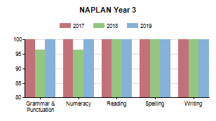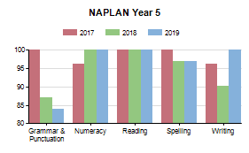
AVERAGE STUDENT ATTENDANCE RATE BY YEAR LEVEL | %
Y01 | 91.3
Y02 | 93.4
Y03 | 91.0
Y04 | 92.6
Y05 | 93.9
Y06 | 91.3
Overall average attendance | 92.3

TEACHING STAFF ATTENDANCE RATE
Teaching Staff Attendance Rate | 93.2%

ALLSTAFF RETENTION RATE
Staff Retention Rate | 93.8%

TEACHER QUALIFICATIONS

Doctorate | 0.0%
Masters | 18.2%
Graduate | 27.3%
Graduate Certificate | 4.5%
Bachelor Degree | 63.6%
Advanced Diploma | 31.8%
No Qualifications Listed | 0.0%

STAFF COMPOSITION

Principal Class (Headcount) | 3
Teaching Staff (Headcount) | 25
Teaching Staff (FTE) | 17.5
Non-Teaching Staff (Headcount) | 10
Non-Teaching Staff (FTE) | 9.5
Indigenous Teaching Staff (Headcount) | 0

